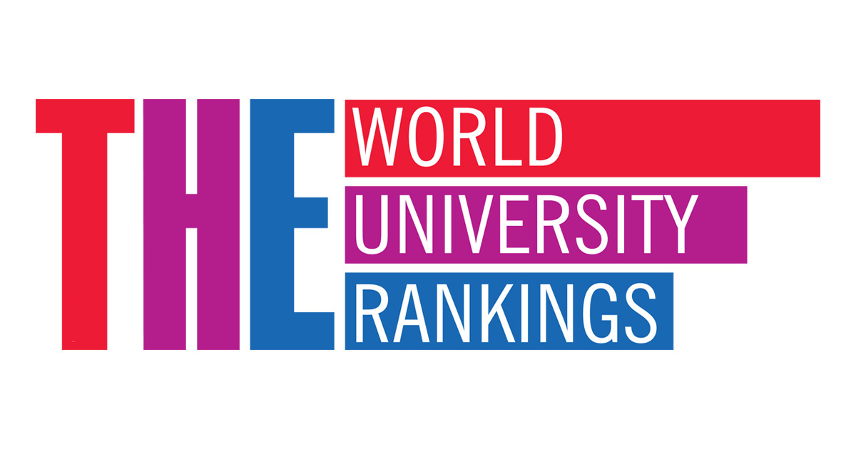

**Team Members:**

Viera Garcia, Caroline Larry, Chithra Mohana Sundaram, Ting Jennings, William Powell

**Topic:**

World University Rankings

Investigate the best universities in the world

**Data Sources:**

<https://www.kaggle.com/mylesoneill/world-university-rankings>

Manually create csv with coordinates for top 15-25 universities

**Questions:**

Which country has the highest number of ranked universities?

How have the university rankings changed between 2012 and 2015?

How do the university rankings change based on different criteria?

Score comparisons:

* university score for research (volume, income and reputation)
* university score for citations (research influence)
* university score international outlook (staff, students, research)
* university score for industry income (knowledge transfer)
* university score for teaching (the learning environment)
* number of students at the university
* number of researchers per university

**Potential Graphs:**

Bar chart: number of top universities in different countries

Represent the top 10 universities on different bar charts with different criteria

Scatterplot

Pie Chart

Line Chart - Top 5 world rank universities by CWUD from 2012-2015

Bubble Chart - (marker_size: , y : , x : )

Spider chart comparing top 3 universities for a specific year

**Interactive Features:**

* Drop-down menu: Filter data by year or by scoring system
* When the user selects a specific university, a pop-up box will appear that includes the university’s information/ scores
* Interactive map of top universities